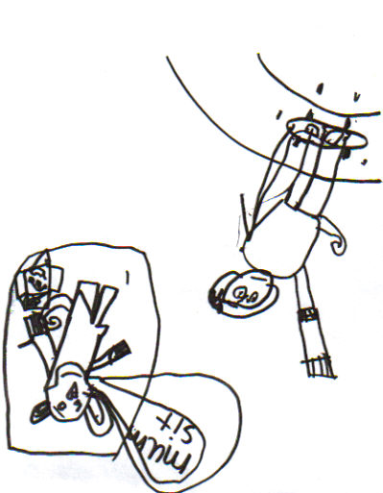
‘What happened next?’ Drawing by K. aged 7 following the reading of ‘Sam’ Unit 1

